AIM: 7 Performing one-way ANOVA using aov() (R).
#CODE:
# Practical 7: One-Way ANOVA
print("Siya Poipkar S105")
mall_data <- read.csv("C:/Users/DELL/Desktop/siya/DATASET/Mall_Customers.csv")
str(mall_data)
colnames(mall_data) <- c(
"CustomerID", "Gender", "Age", "AnnualIncome", "SpendingScore"
)
mall_data$AnnualIncome <- as.numeric(mall_data$AnnualIncome)
summary(mall_data$AnnualIncome)
mall_data$Income_Group <- cut(
mall_data$AnnualIncome,
breaks = c(15, 40, 70, 137),
labels = c("Low", "Medium", "High"),
include.lowest = TRUE
)
mall_data$Income_Group <- droplevels(mall_data$Income_Group)
table(mall_data$Income_Group)
anova_one <- aov(SpendingScore ~ Income_Group, data = mall_data)
summary(anova_one)
#OUTPUT:
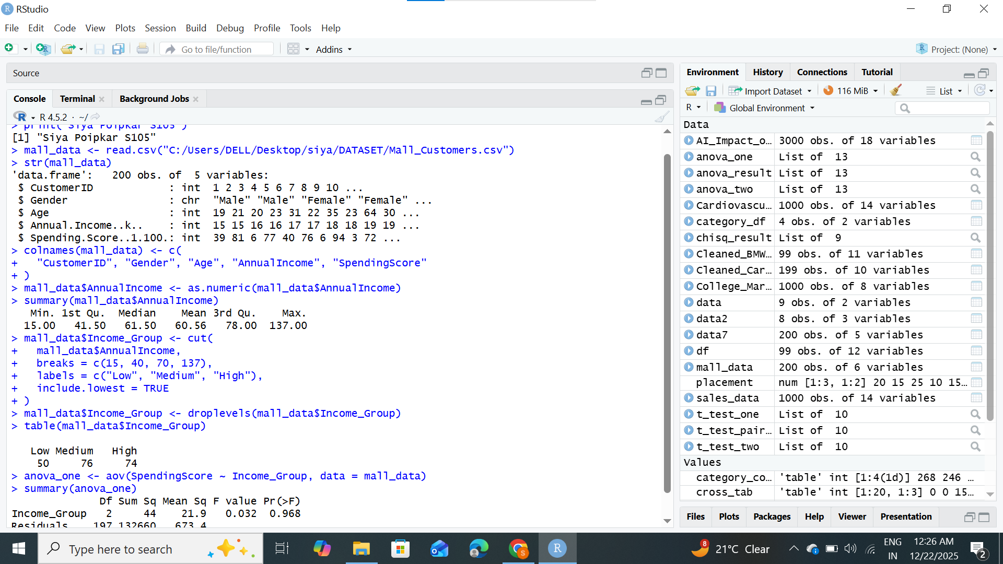

AIM: 8 Performing two-way ANOVA using aov() (R).

#CODE:
# Practical 8: Two-Way ANOVA
print("Siya Poipkar S105")
ai_data <- read.csv("C:/Users/DELL/Desktop/siya/DATASET/AI_Impact_on_Jobs_2030.csv")

str(ai_data)

colnames(ai_data) <- gsub(" ", "_", colnames(ai_data))

ai_data$Average_Salary <- as.numeric(ai_data$Average_Salary)

ai_data$Education_Level <- as.factor(ai_data$Education_Level)
ai_data$Risk_Category <- as.factor(ai_data$Risk_Category)

ai_data$Education_Level <- droplevels(ai_data$Education_Level)
ai_data$Risk_Category <- droplevels(ai_data$Risk_Category)

table(ai_data$Education_Level)
table(ai_data$Risk_Category)

anova_two <- aov(Average_Salary ~ Education_Level * Risk_Category, data = ai_data)

summary(anova_two)

#OUTPUT: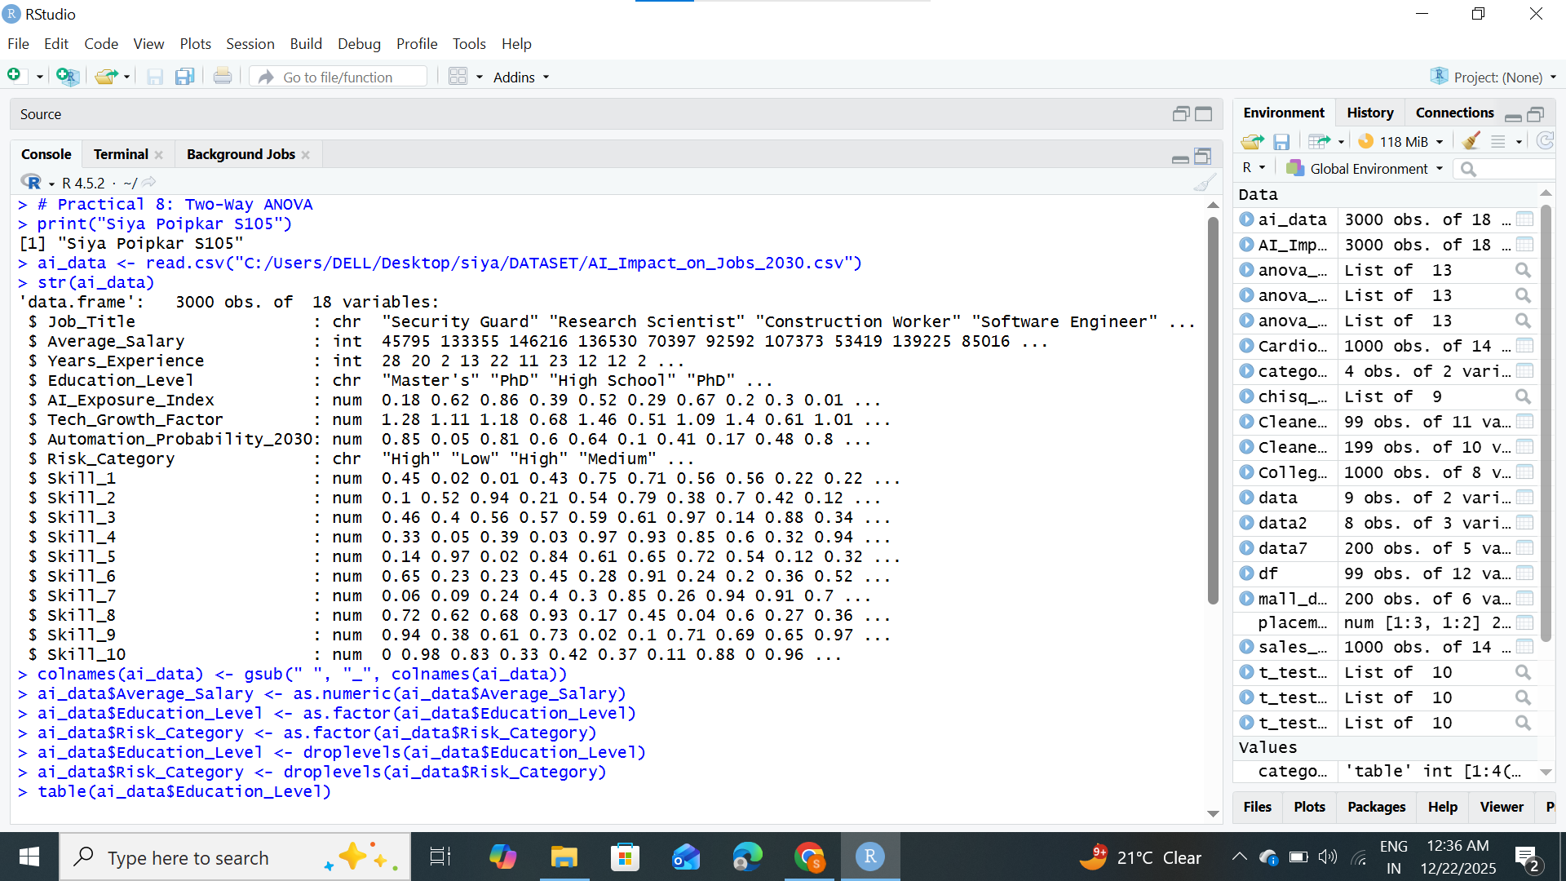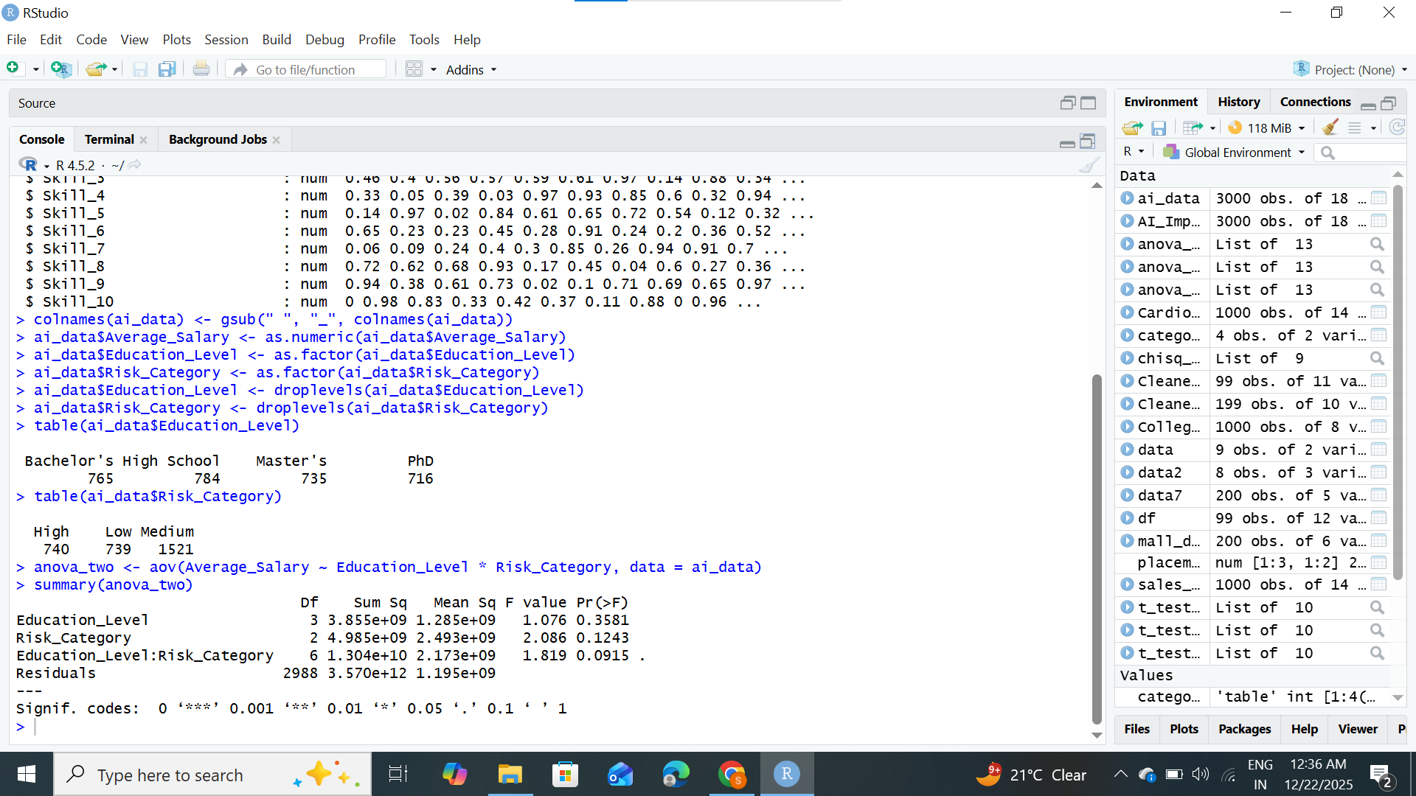

AIM: 9 Conducting Chi-square tests using chisq.test() (R)

#CODE:
# Practical 9: Chi-Square Test
print("Siya Poipkar S105")
heart_data <- read.csv("C:/Users/DELL/Desktop/siya/DATASET/Cardiovascular_Disease_Dataset.csv")

str(heart_data)

colnames(heart_data) <- gsub(" ", "_", colnames(heart_data))

heart_data$gender <- as.factor(heart_data$gender)
heart_data$target <- as.factor(heart_data$target)

heart_data$gender <- droplevels(heart_data$gender)
heart_data$target <- droplevels(heart_data$target)

cont_table <- table(heart_data$gender, heart_data$target)

cont_table

chi_result <- chisq.test(cont_table)

chi_result

#OUTPUT: